

**Format No. QSP/7.1/01.F01 (B) Issue No.05 Rev. No 5 Dated: Jan 1, 2017**

**UNIVERSITY OF PETROLEUM & ENERGY STUDIES**

**College of Engineering Studies Dehradun**

**LAB FILE**

Programme : B. Tech in Computer Science and Engineering with Specialization in DevOps

Course : Build and Release Management Lab No. of credits : 1

Semester IV

Session : Jan-May 2020

Batch : 2018-2022

Faculty : Dr. Hitesh Kumar Sharma

**Submitted By:**

**Roll No R171218116**

**Name KUSHAGRA BANSAL**

**Faculty Signature**

***LAB EXERCISE 1***

**Aim:**

1. **Create a Java Project using Maven.**

***Step 1:***

* Go to new > others and click

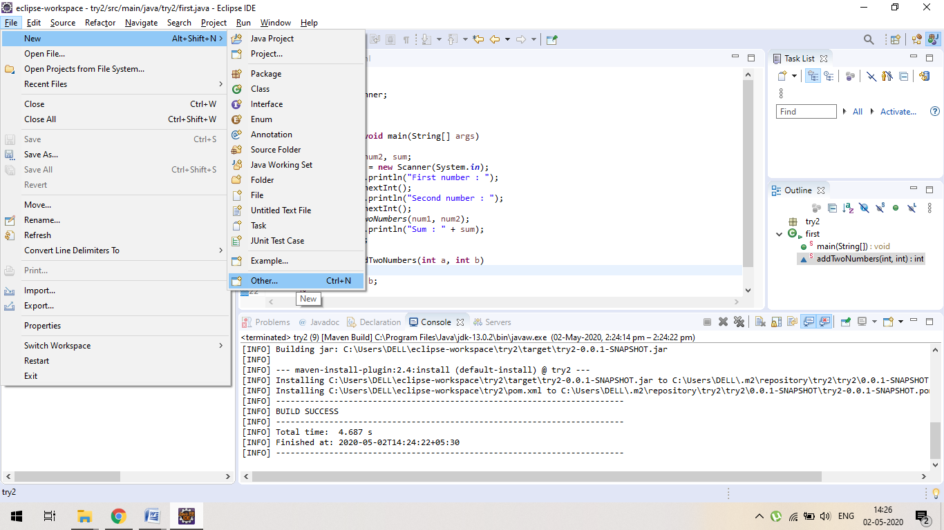

**Step 2 :**

* Search Maven and click on Maven Project

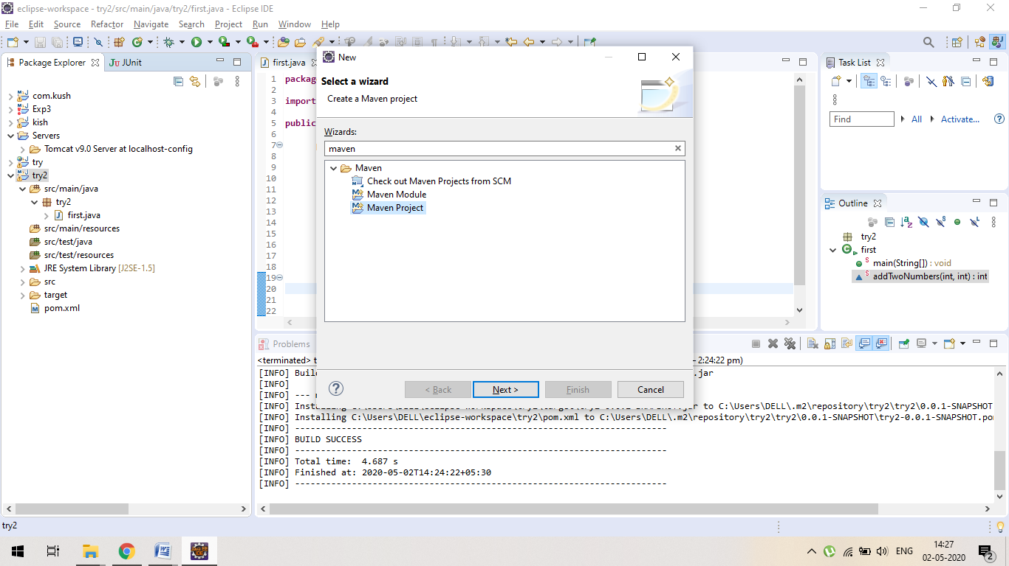

***Step3 :***

* ***Tick on skip archetype selection and press on NEXT.***

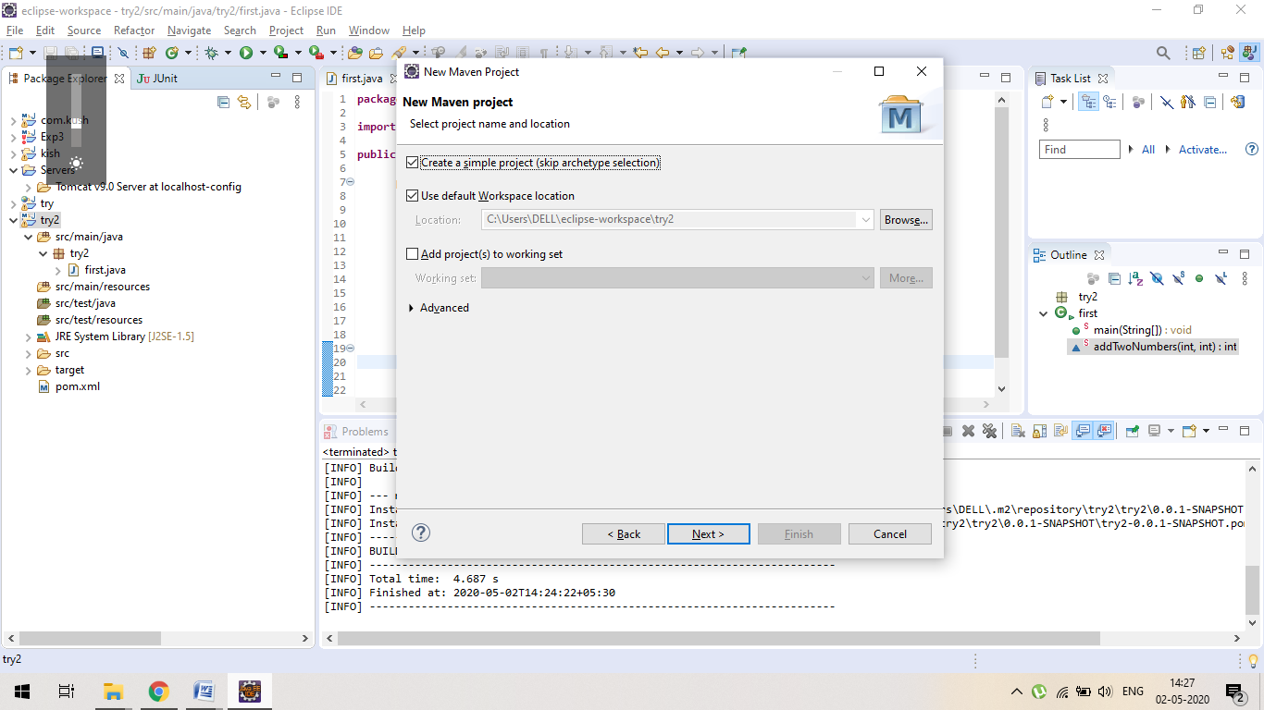

***Step4 :***

* Give Group id and Artifact id and press ***FINISH.***

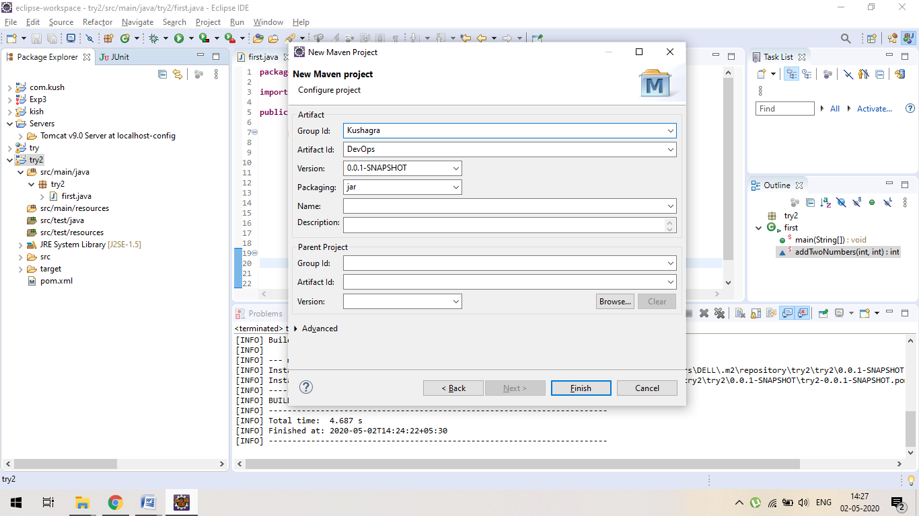

***Step5 :***

Open pom.xml to verify.

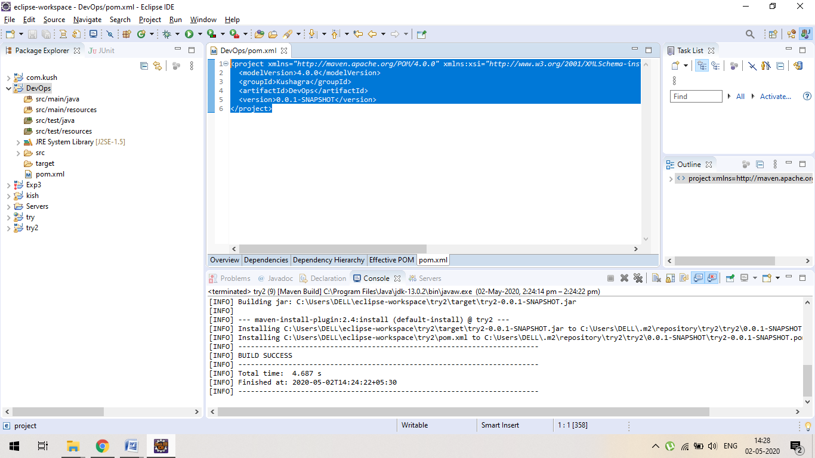

2. Run the following maven goals on this project

• Clean

• Compile

• Test-Compile

• Install

1. CLEAN

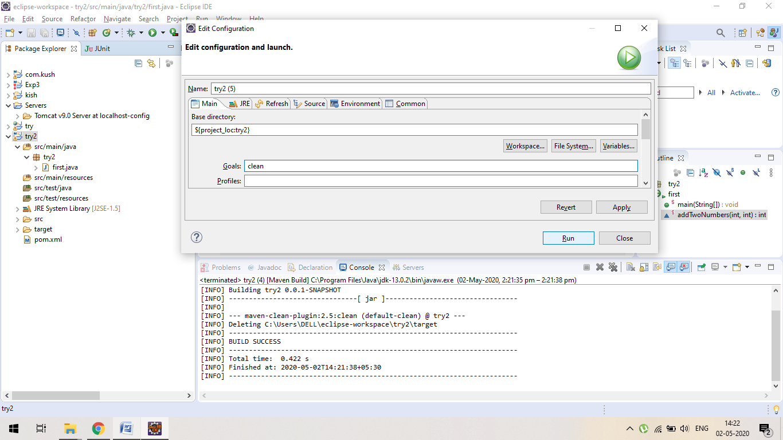

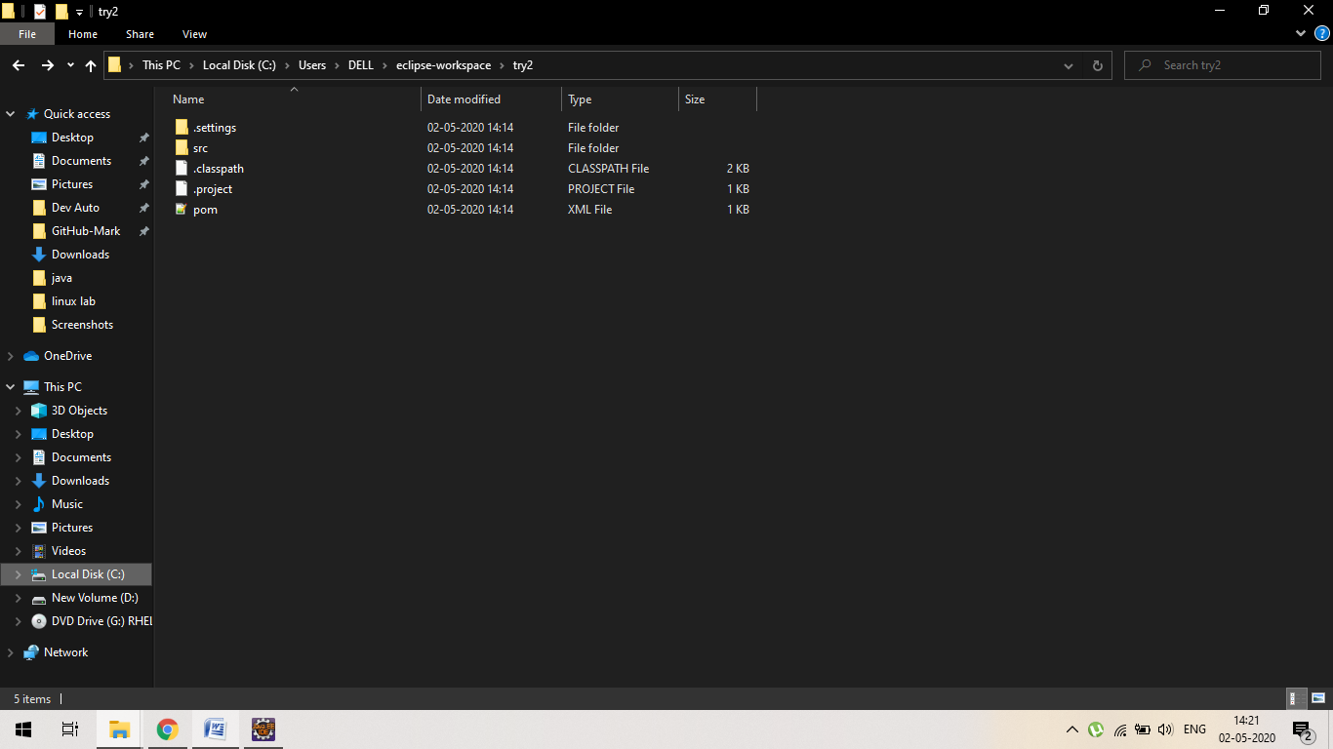

1. Compile

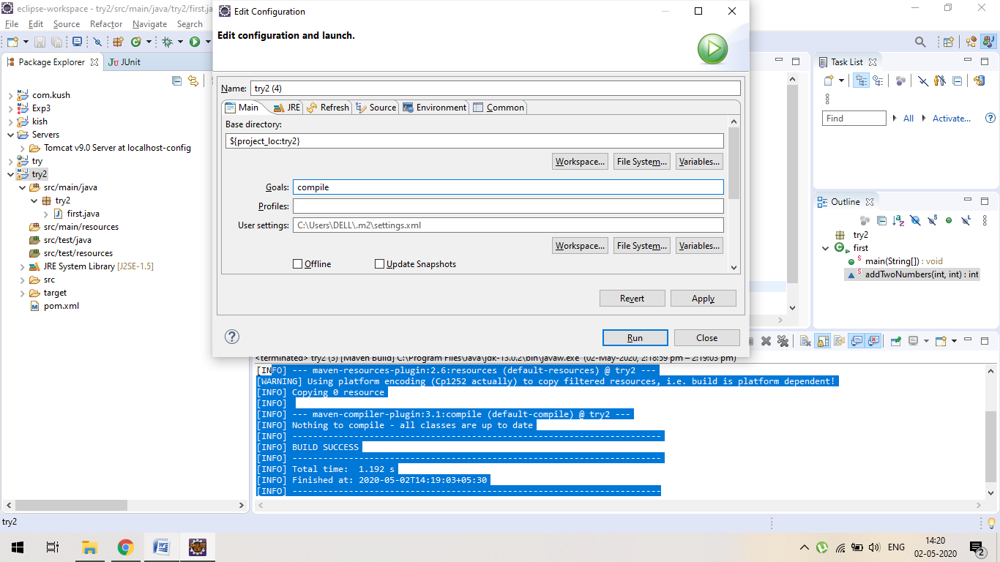

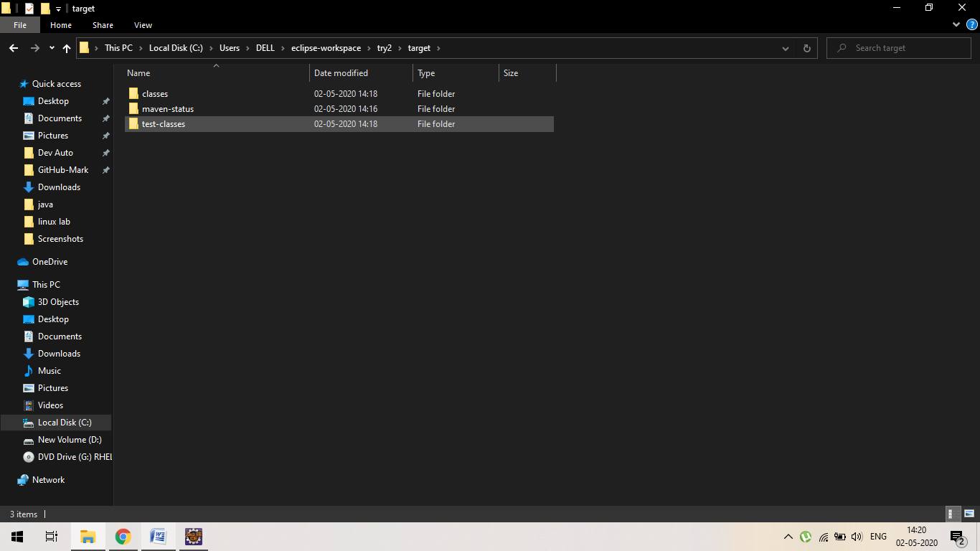

1. Test-compile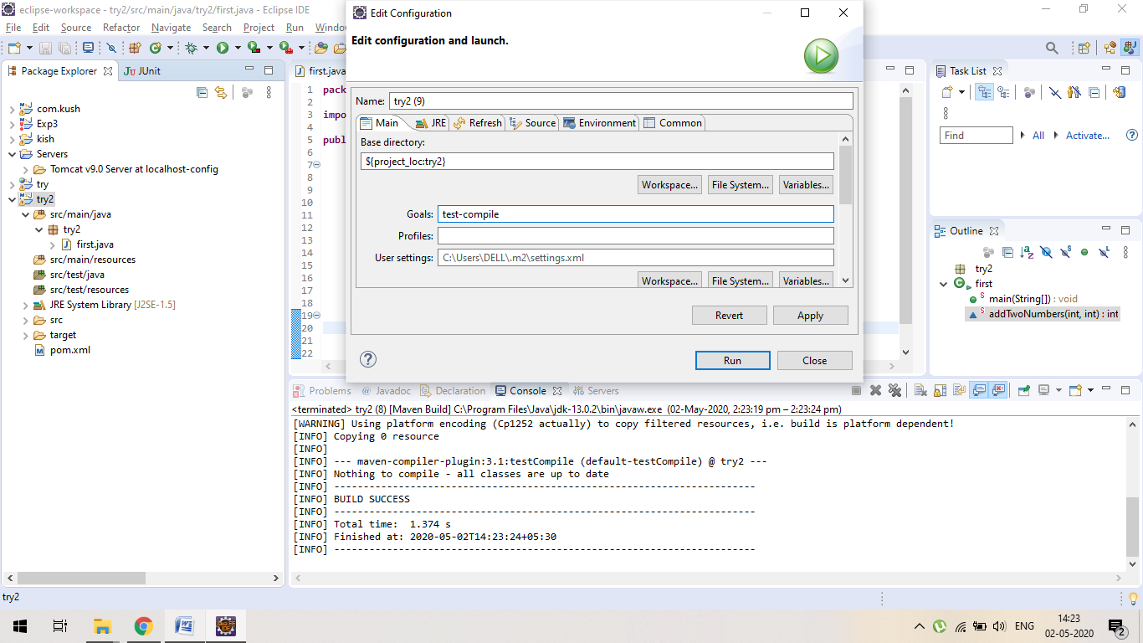



1. Install :

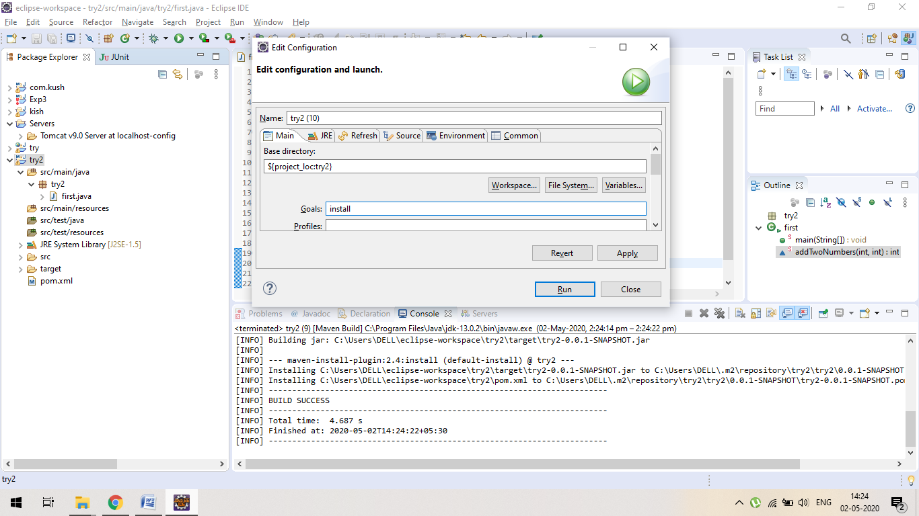

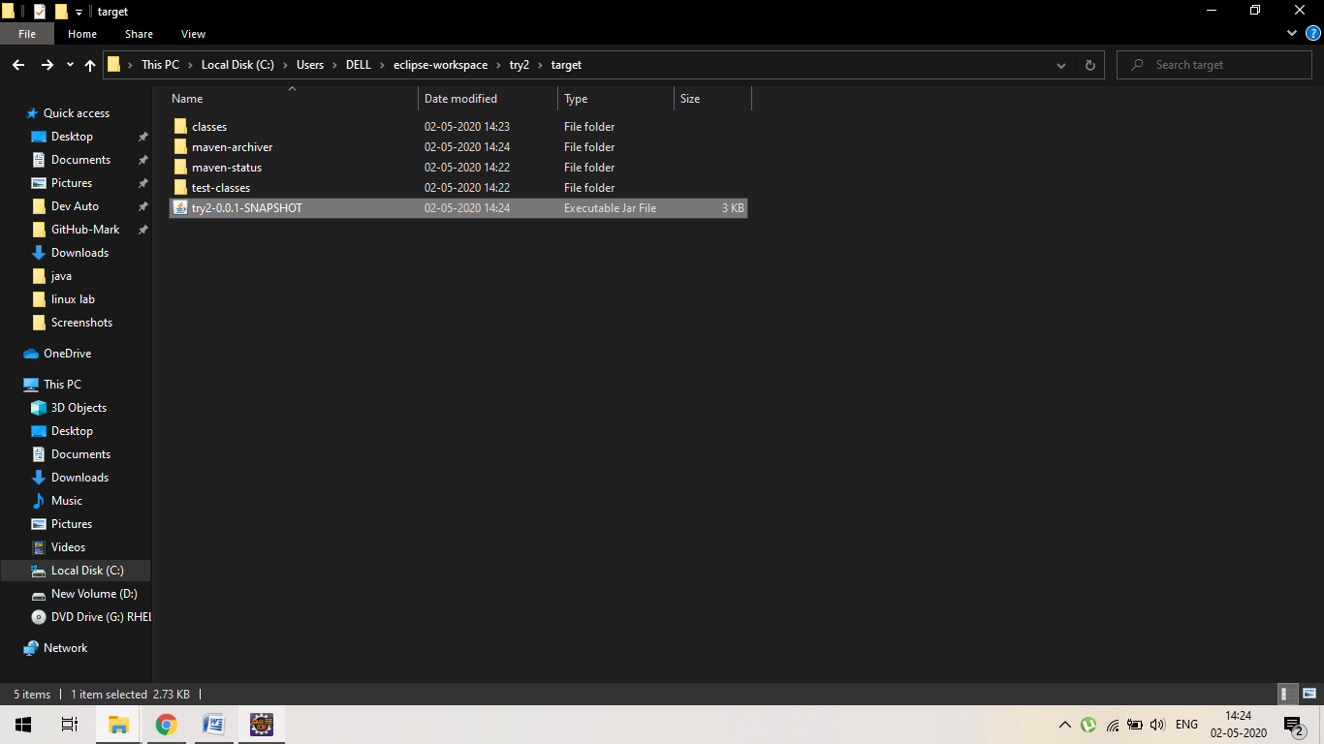

**LAB EXERCISE 2**

Aim: Unit Testing using Junit tool

Q1. Write a program in java to find sum of two numbers and test this unit with JUnit tool.

Note: use jar file or can use dependencies

Using depencies of junit and hamcrest-core

Ans: first.java 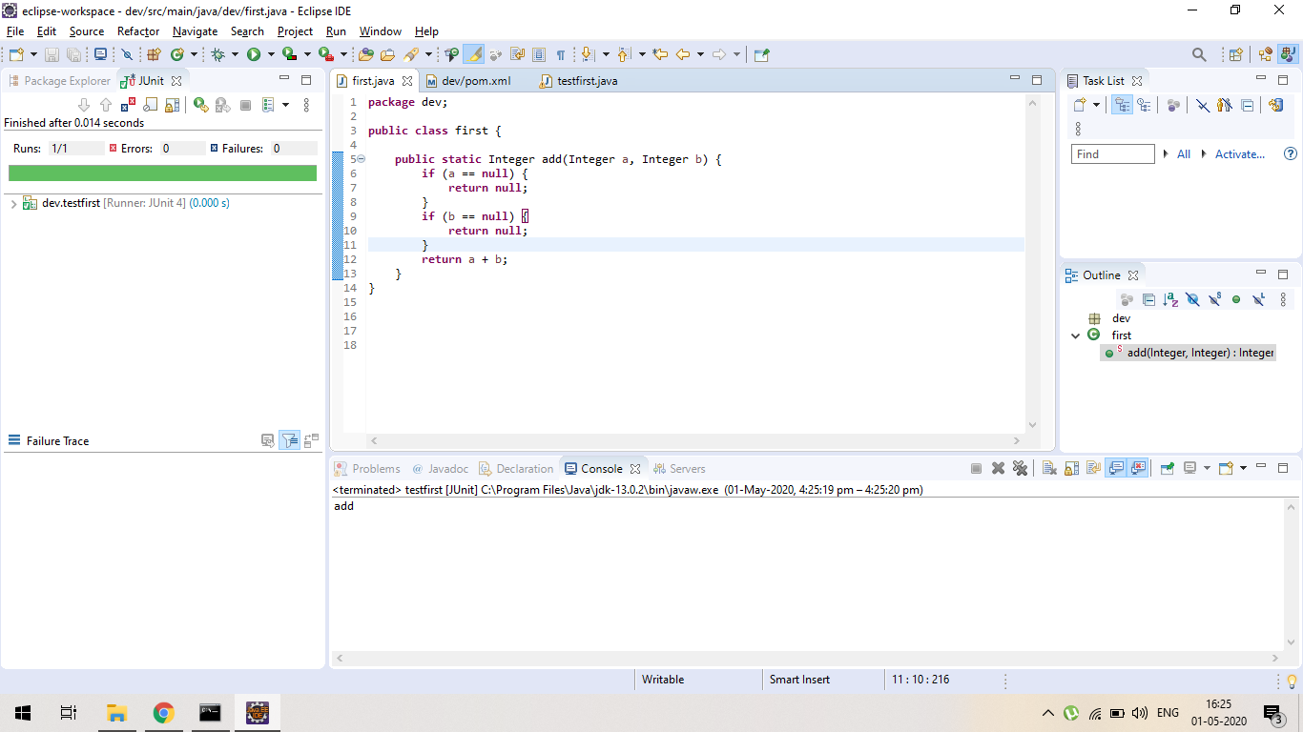

Testfirst.java file

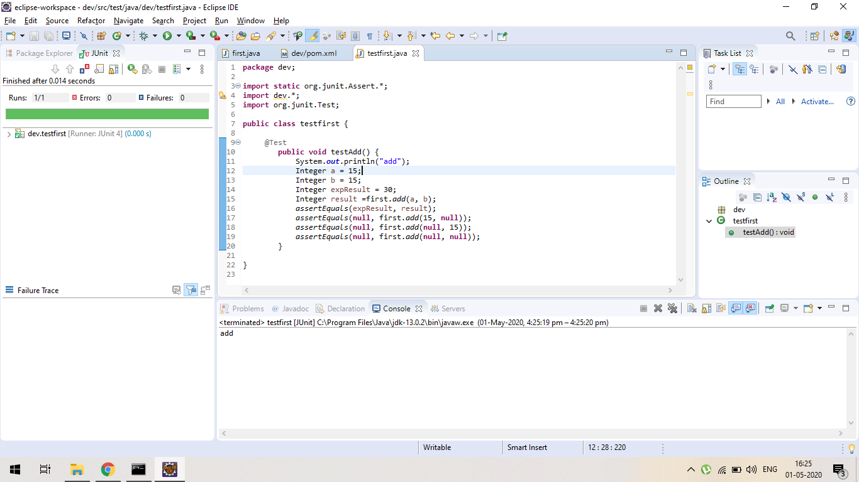

Pom.xml

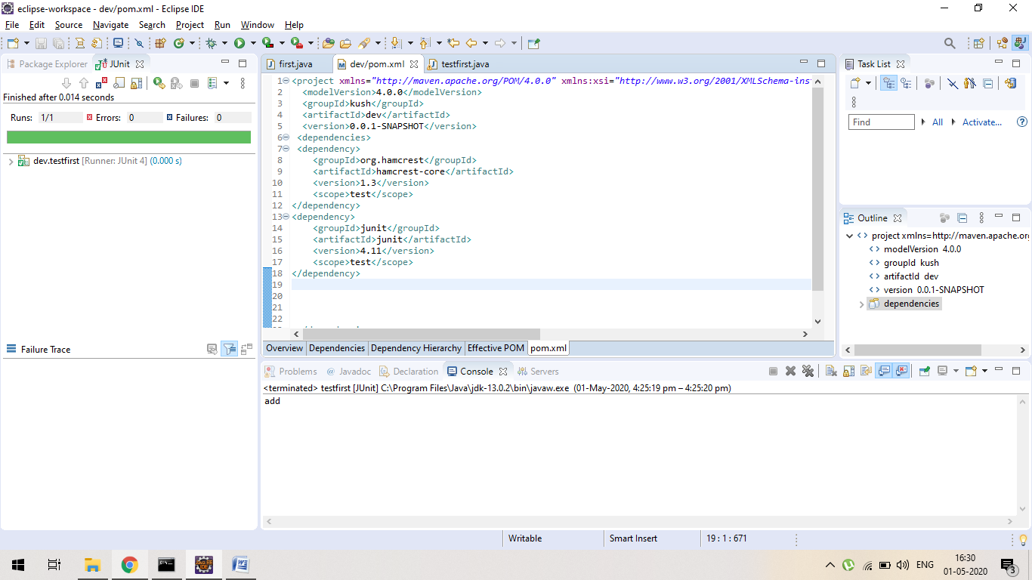

Ques2: Write a program in java to find max value in a given array?

Ans: a) testfirst.java ( using = max = 0)

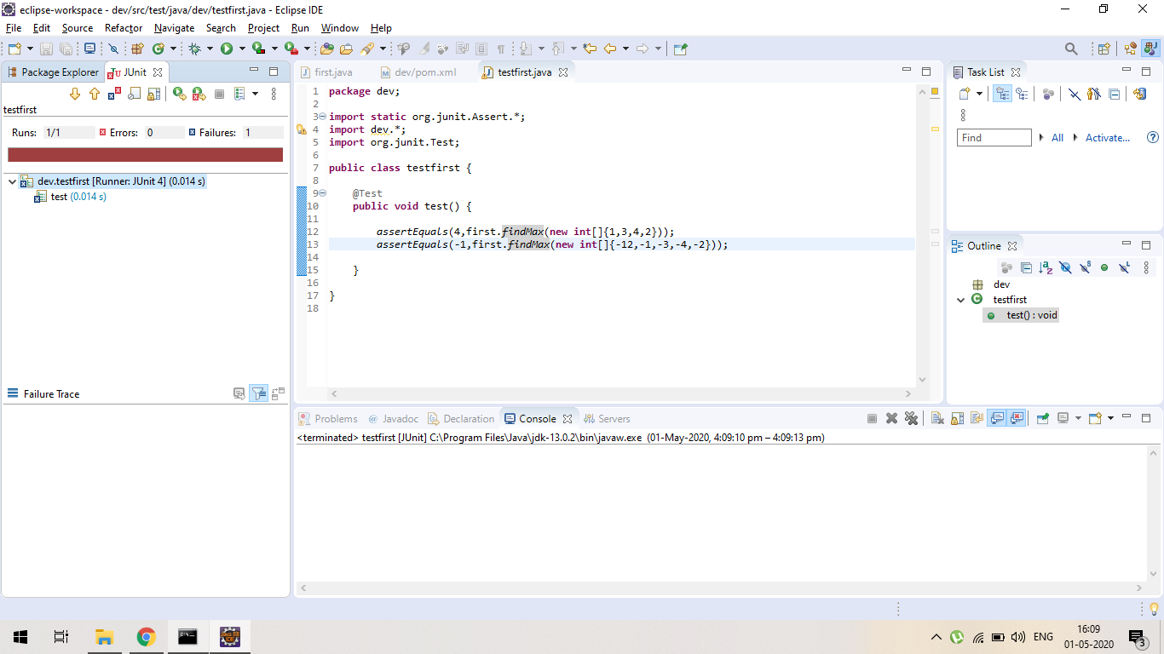

First.java

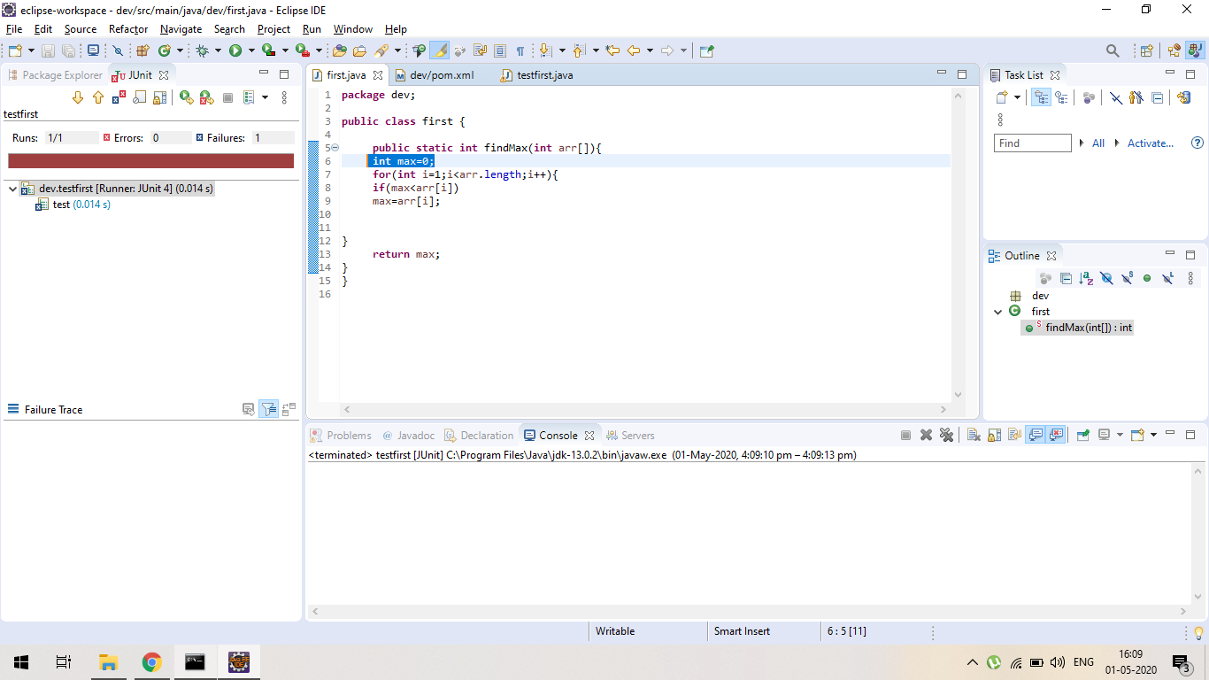

b) first.java ( using max = arr[0] )

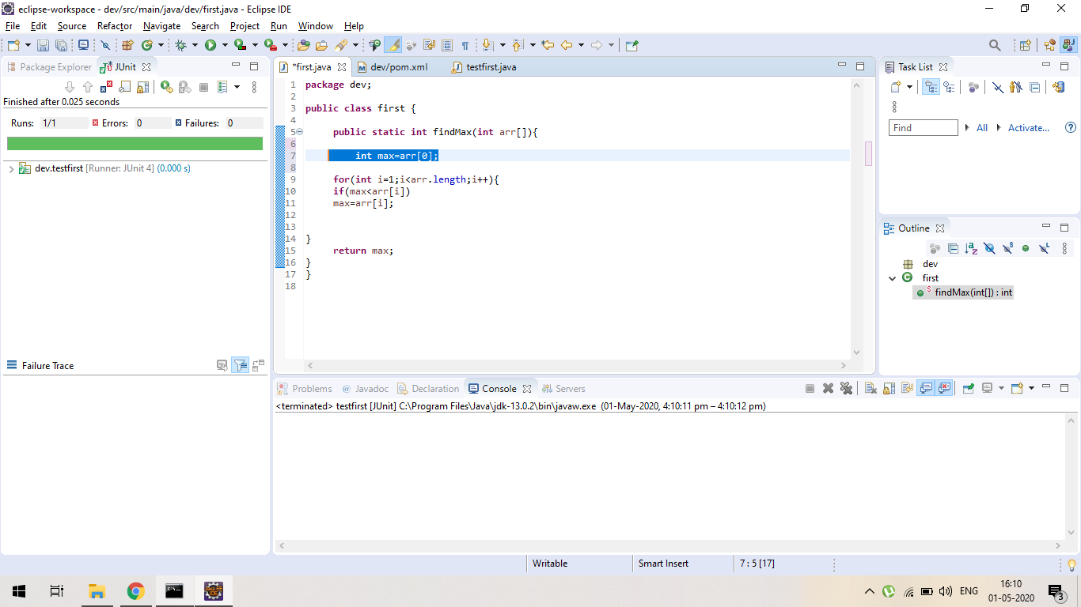

Testfirst.java



***EXPERIMENT 3***

**Maven Build and usage in other Java Project**

**1. Create a Build of java project using maven.**

**2. Use that build in some other Java Project.**

**Adding external jar to our new project:**

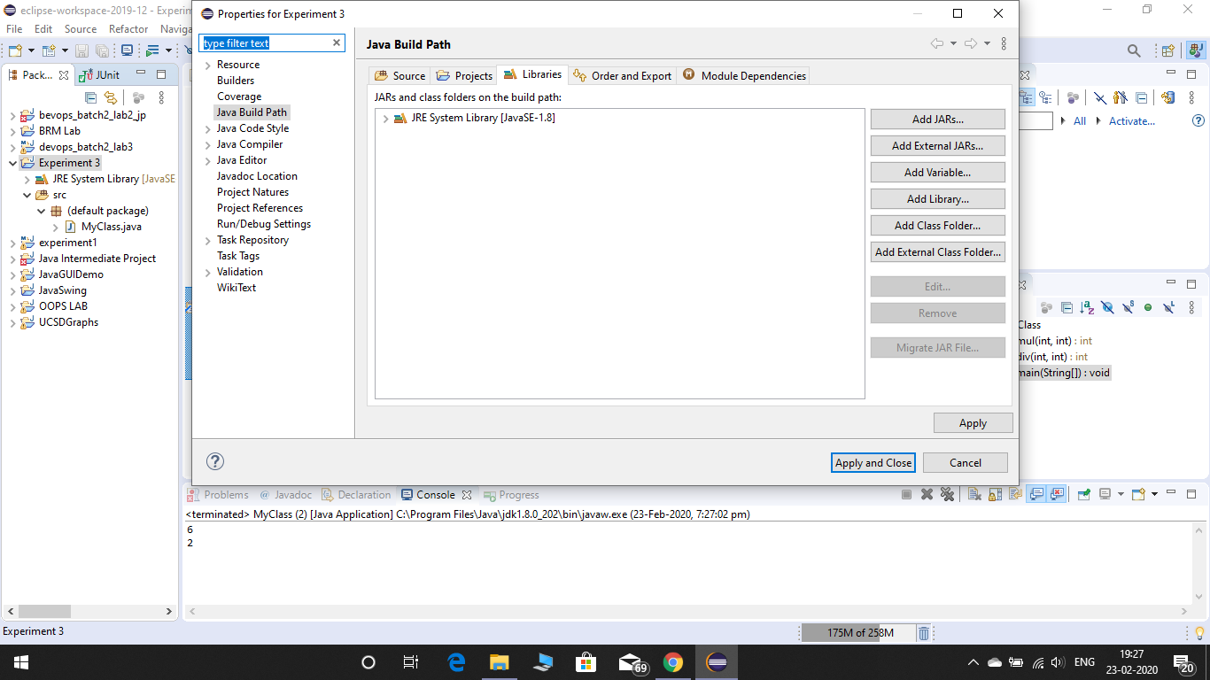

**Using the externally added Maven project in our new Java project:**

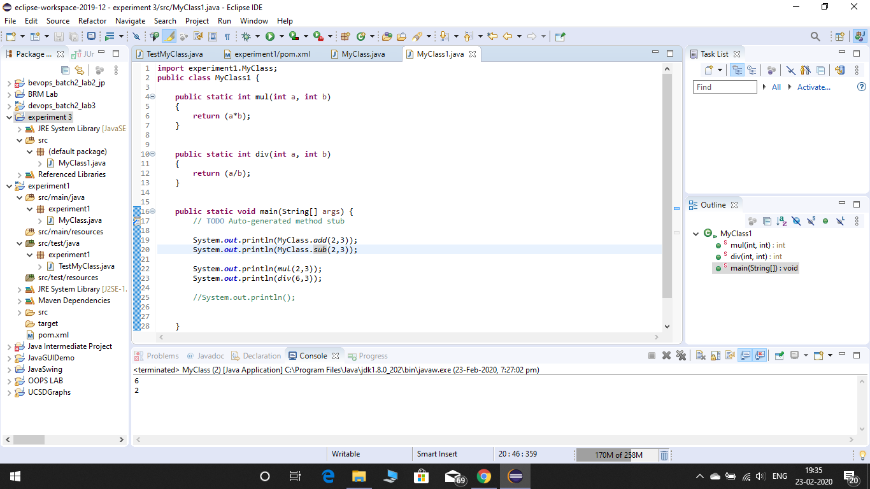

**Checking the jar file of the imported maven project:**

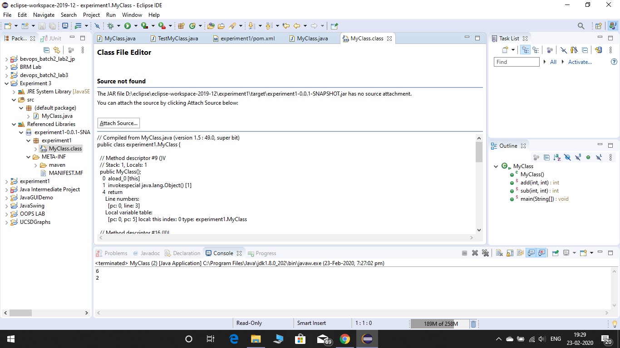

***LAB EXERCISE 4***

Aim: Install and Manage Maven Plugin

1. Install Site Plugin and use “mvn site” command and goal for generating documents for Maven Project.

Using command line:

* Creating maven project:

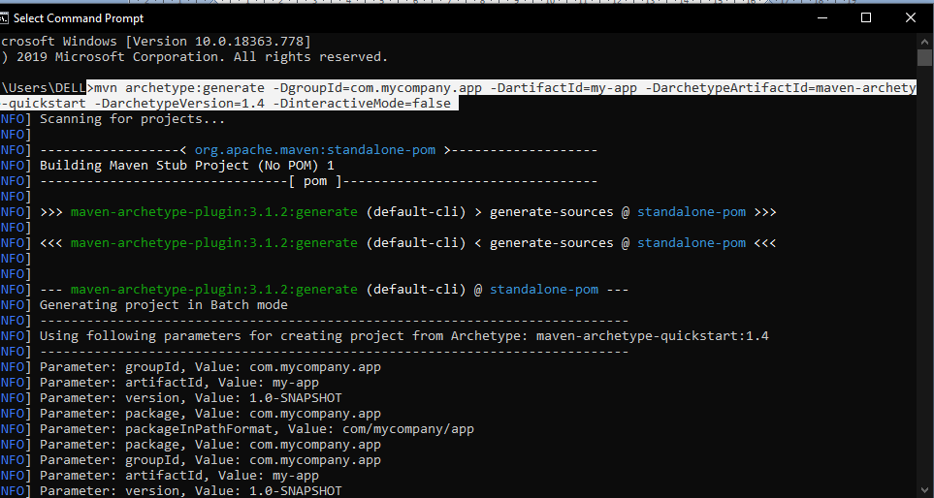

* Using site plugin :

The Site Plugin is used to generate a site for the project. The generated site also includes the project's reports that were configured in the POM.

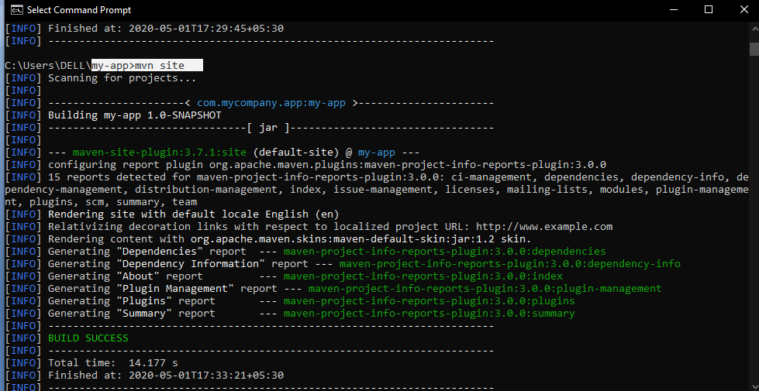

Project info:

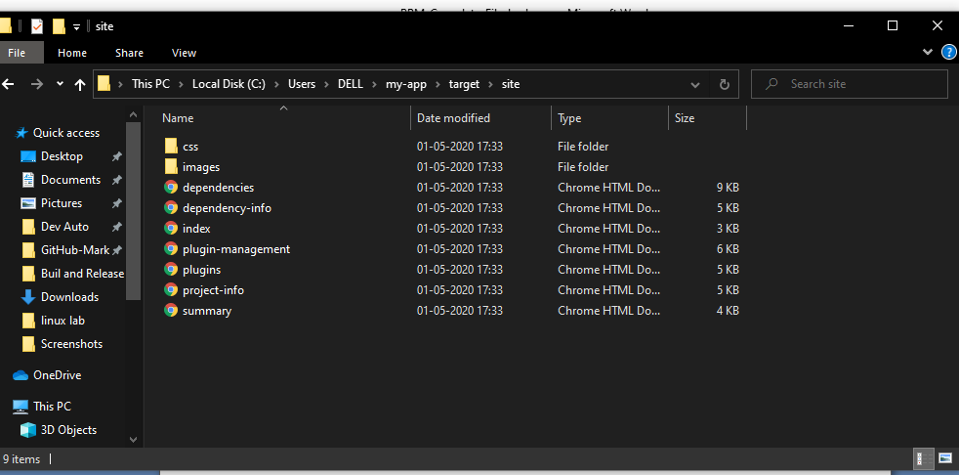

***LAB EXERCISE 5***

Aim: Working with Maven Repository

1. Add Central Repository (Hibernate)

Using dependency of hibernate

As we can see this dependency is available at central repository.

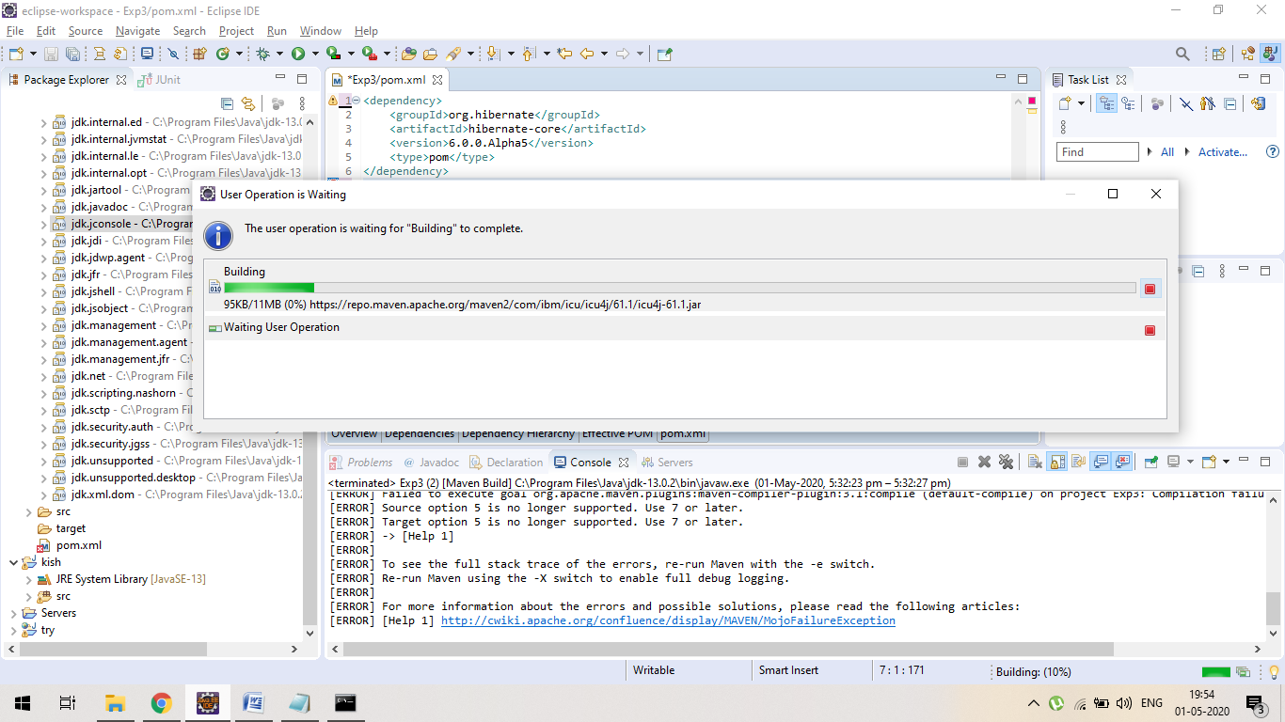

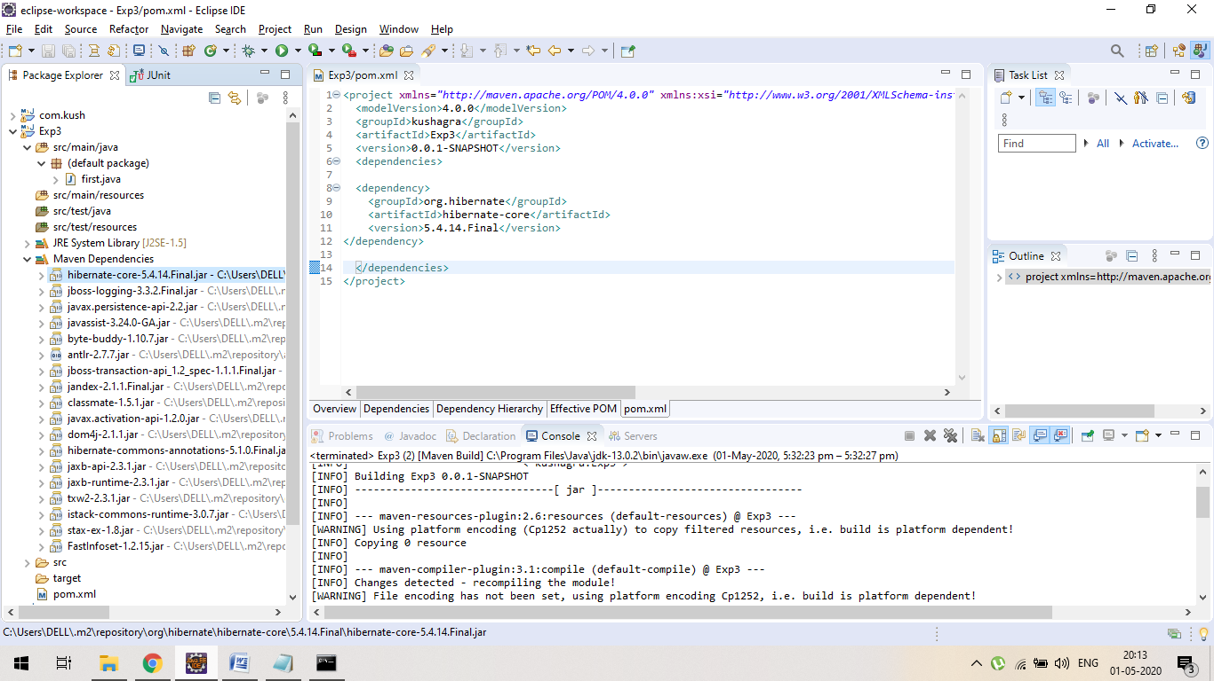

1. Add Remote Repository (Atlassian Mail)

as it’s a remote we have give id,name and URL where the remote Repo is available.

1. If we use dependency without any url in POM file it will show the error.( See Screenshot) :

No maven dependencies directory will be create.

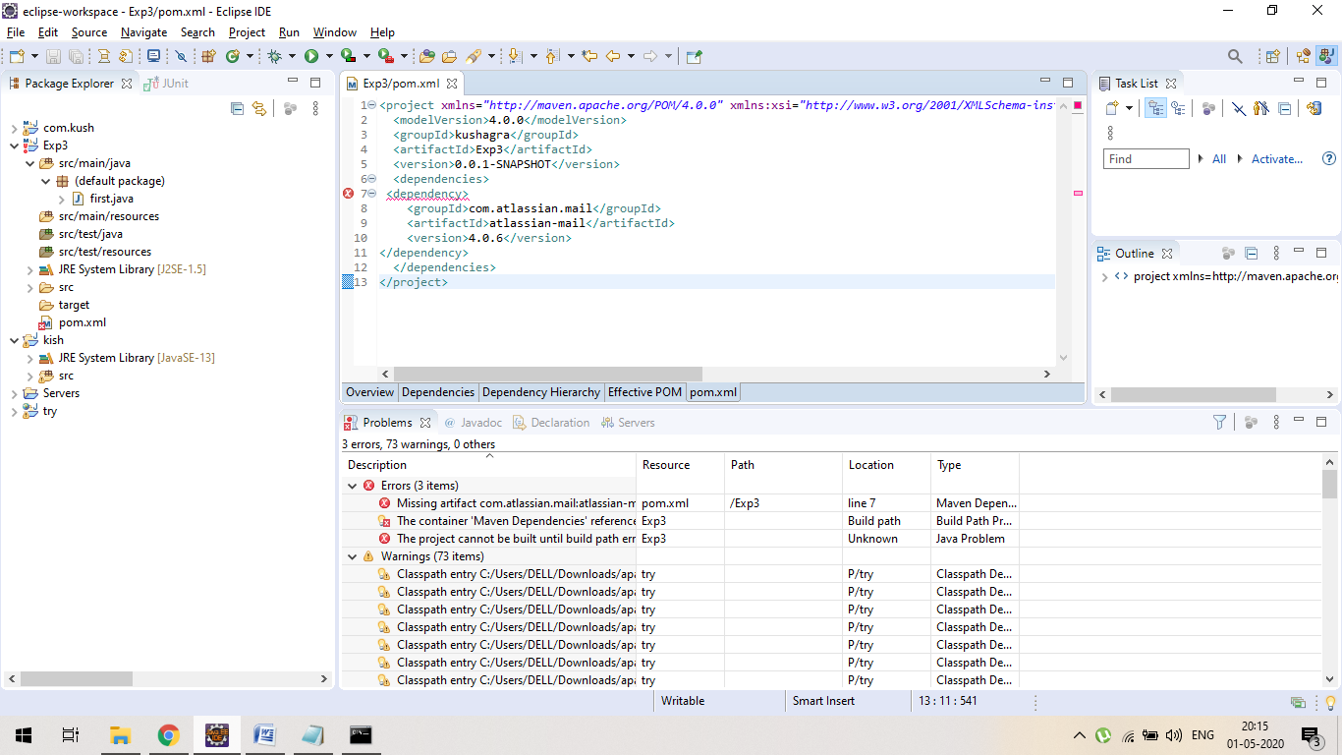

1. **We have to provide proper URL OF REPOSITORY:**

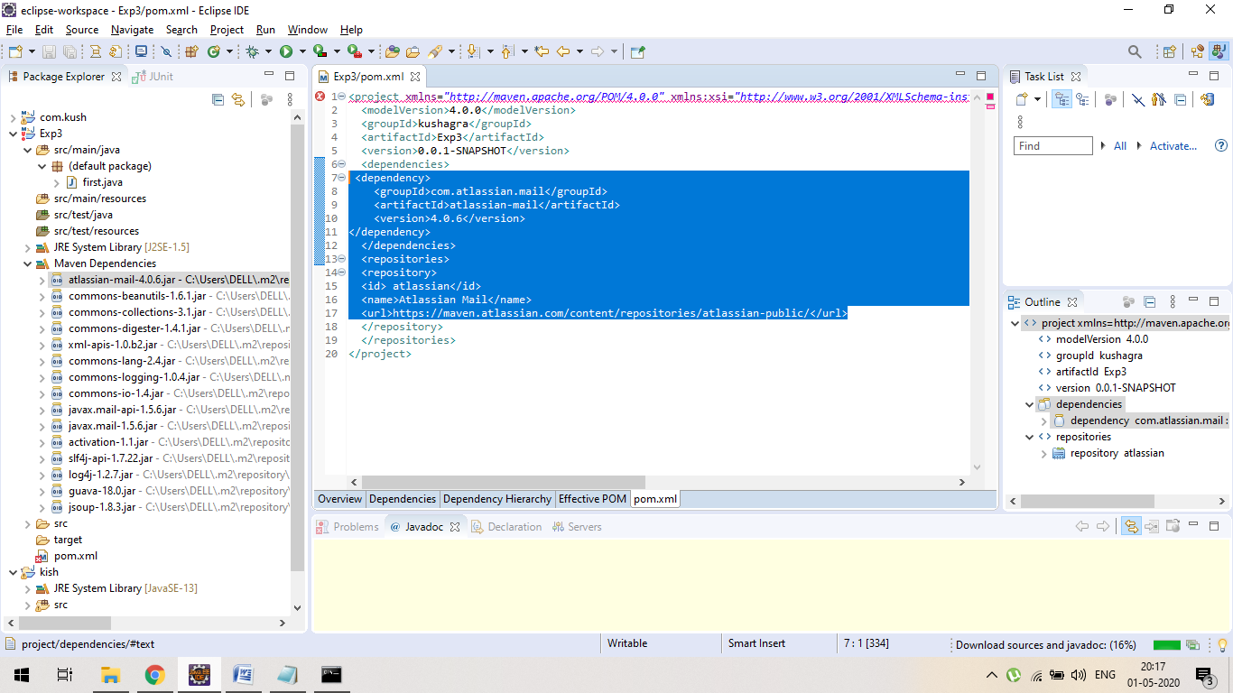

**EXPERIMENT-6**

NAME : KUSHAGRA BANSAL ROLL_NO = 116 SAP_ID : 500067414

Ques : Create a simple Maven Project using CLI.

1. ***Mvn compile***

compile the source code of the project.

Output

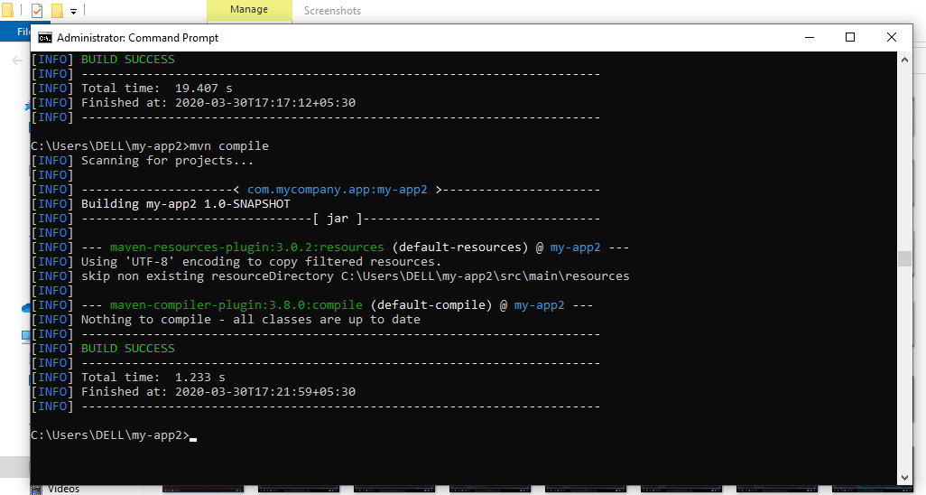:

1. ***Mvn test***:

test the compiled source code using a suitable unit testing framework. These tests should not require the code be packaged or deployed

output:

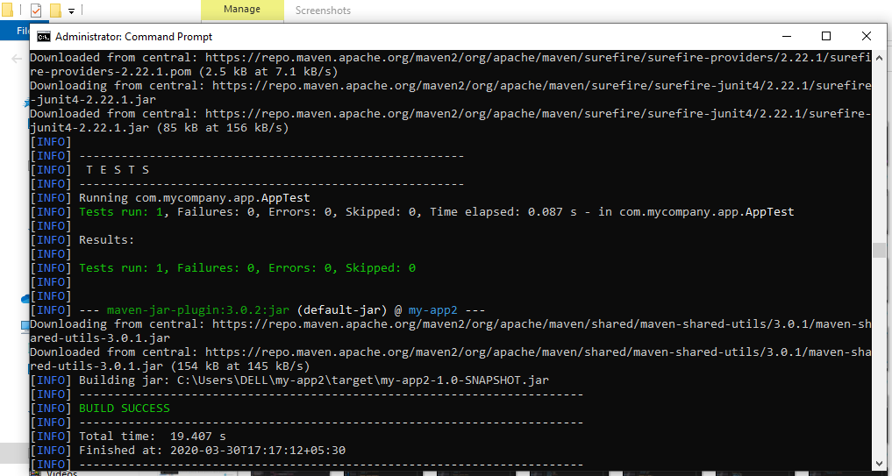

1. ***Mvn test-compile***

Output:

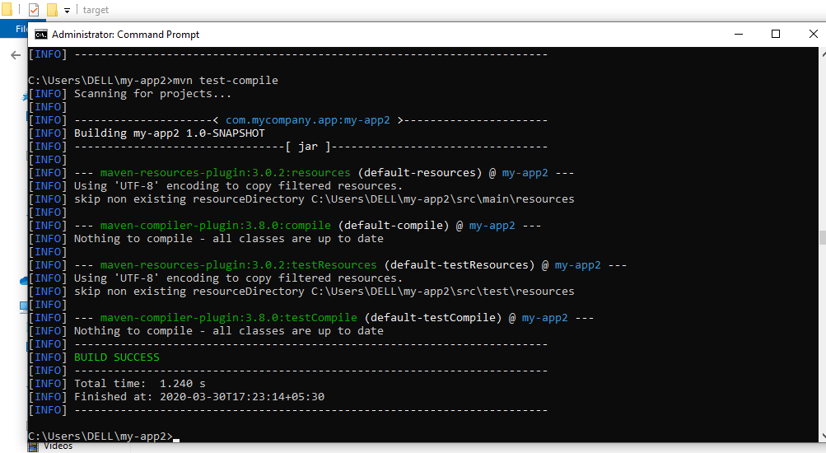

1. ***Mvn site:***

generates site documentation for this project.

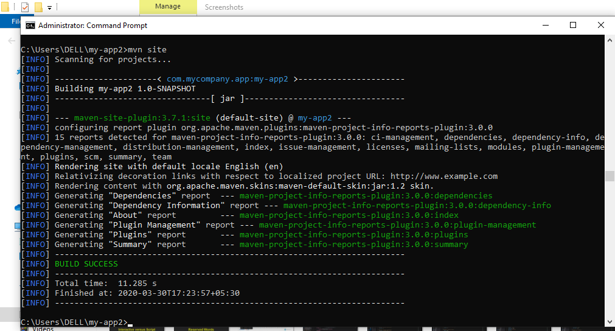

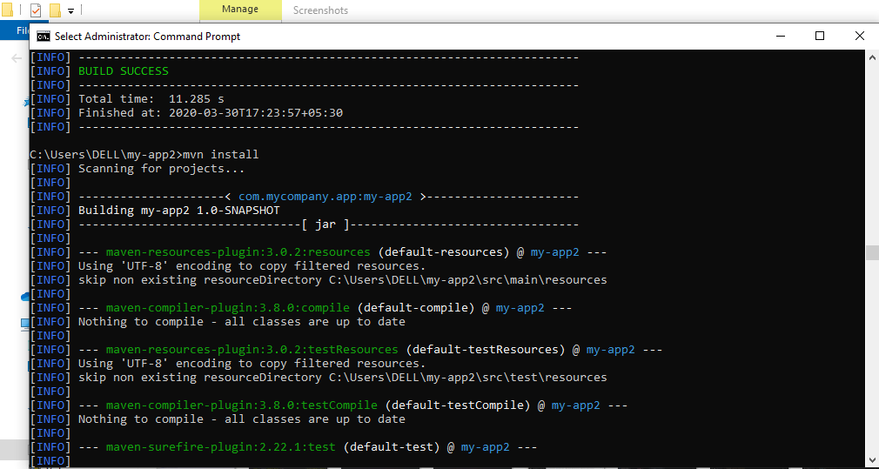

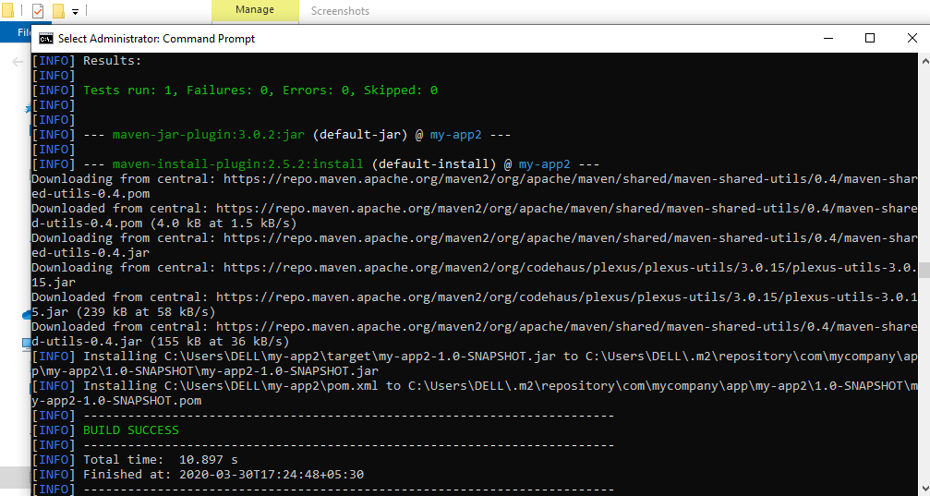

output:

1. ***Mvn validate:***

validate the project is correct and all necessary information is available

output:

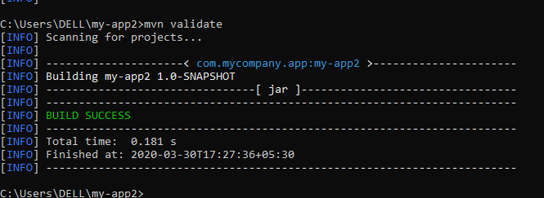

1. ***Mvn verify:***

run any checks to verify the package is valid and meets quality criteria.

Output:

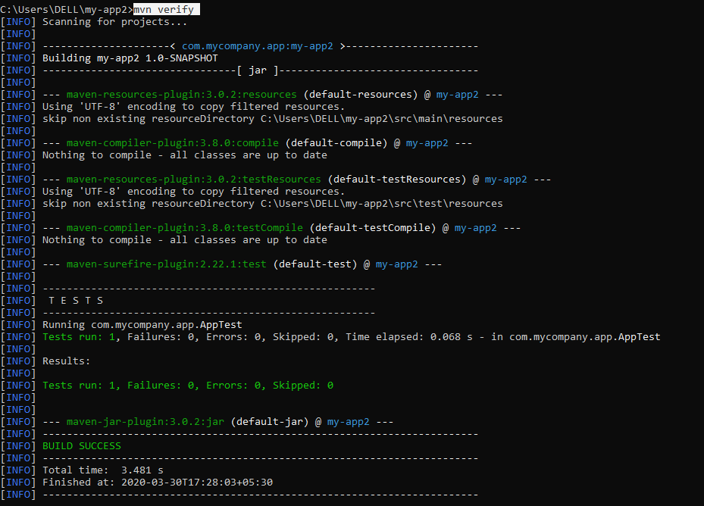

1. ***Mvn clean :***

* cleans up artifacts created by prior builds

1. Before clean: we can see target folder :

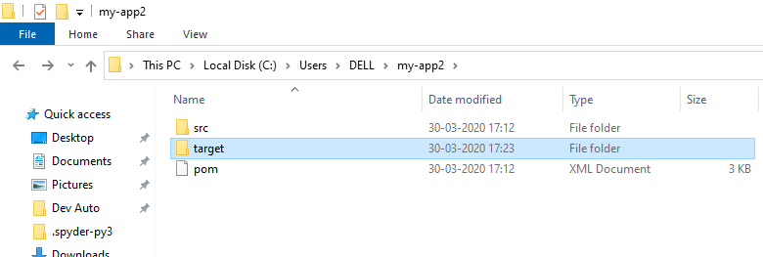

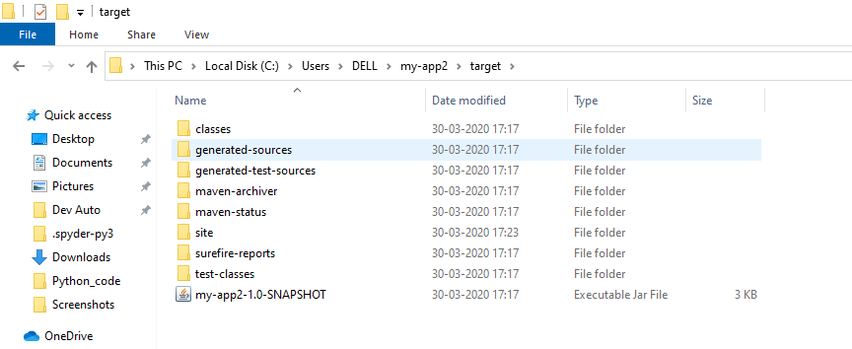

1. After mvn clean: u will no target folder will be there.

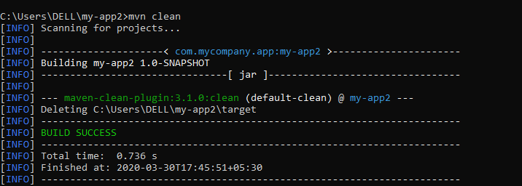

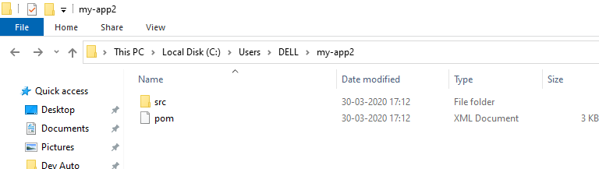

***Experiment-7***

Ques1 : Selenium Automation Test Script.

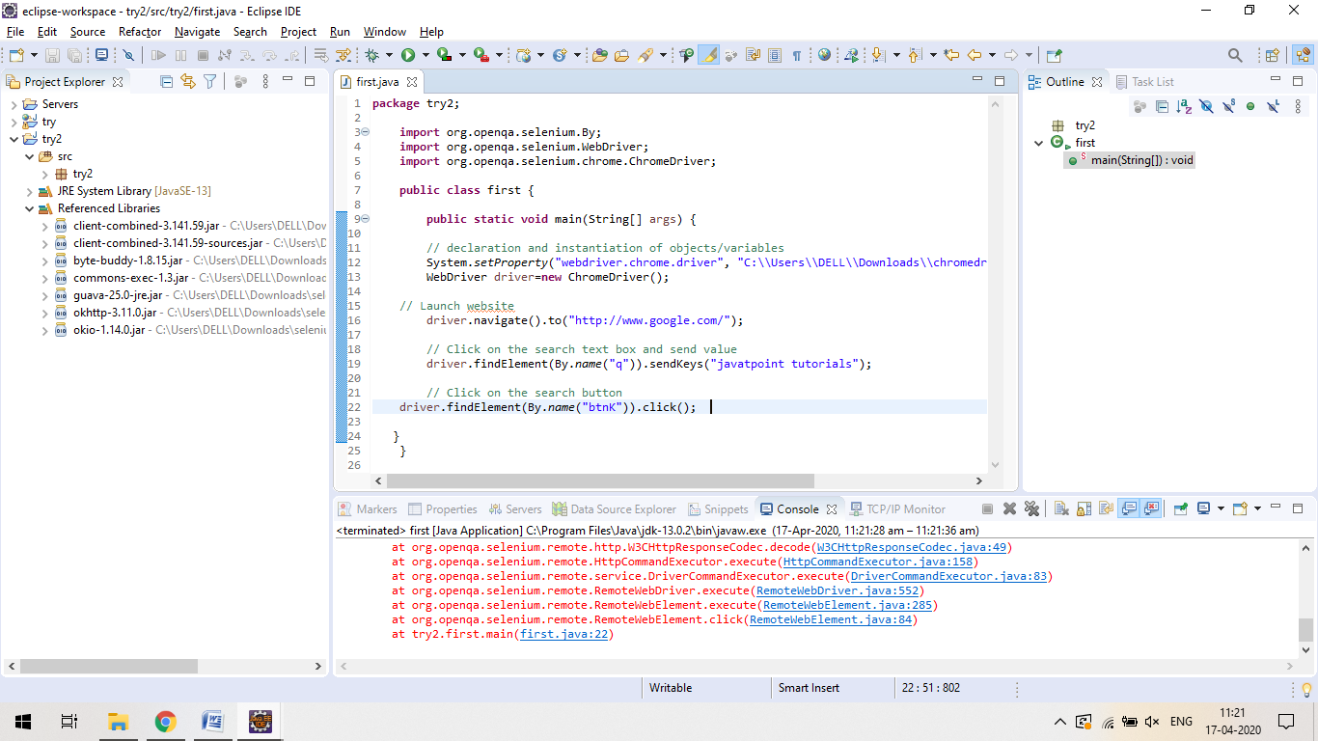

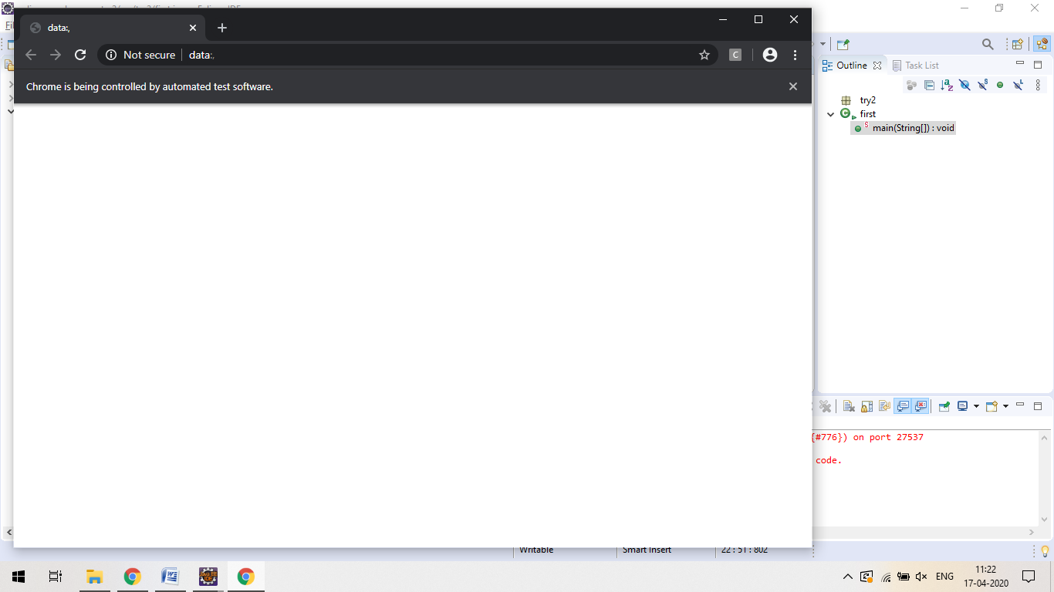

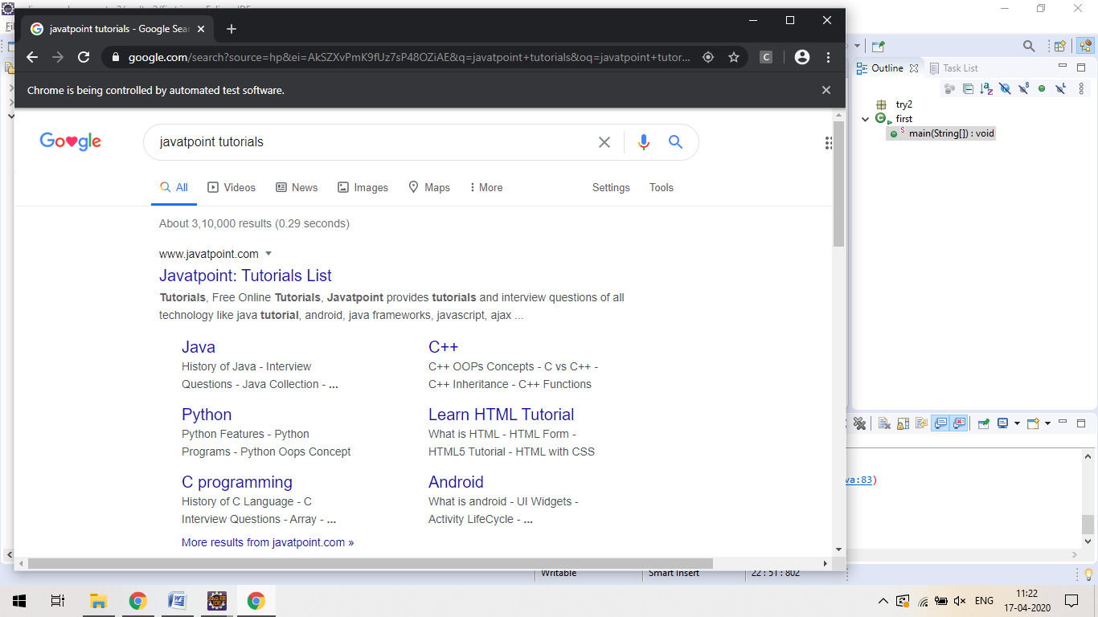

Ques2: About some of the most commonly used Browser commands for Selenium WebDriver.

Ans:

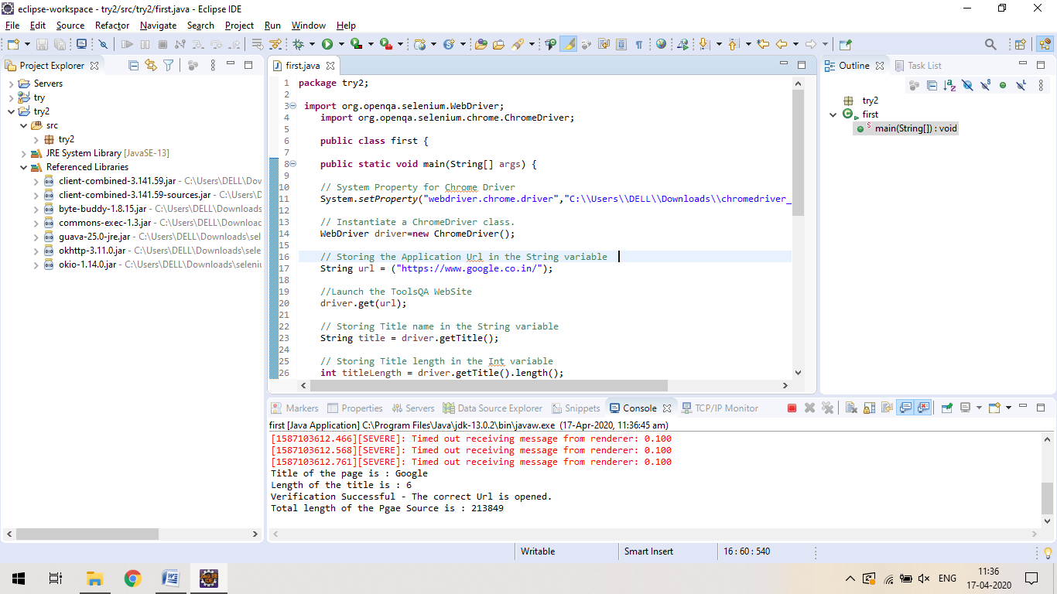

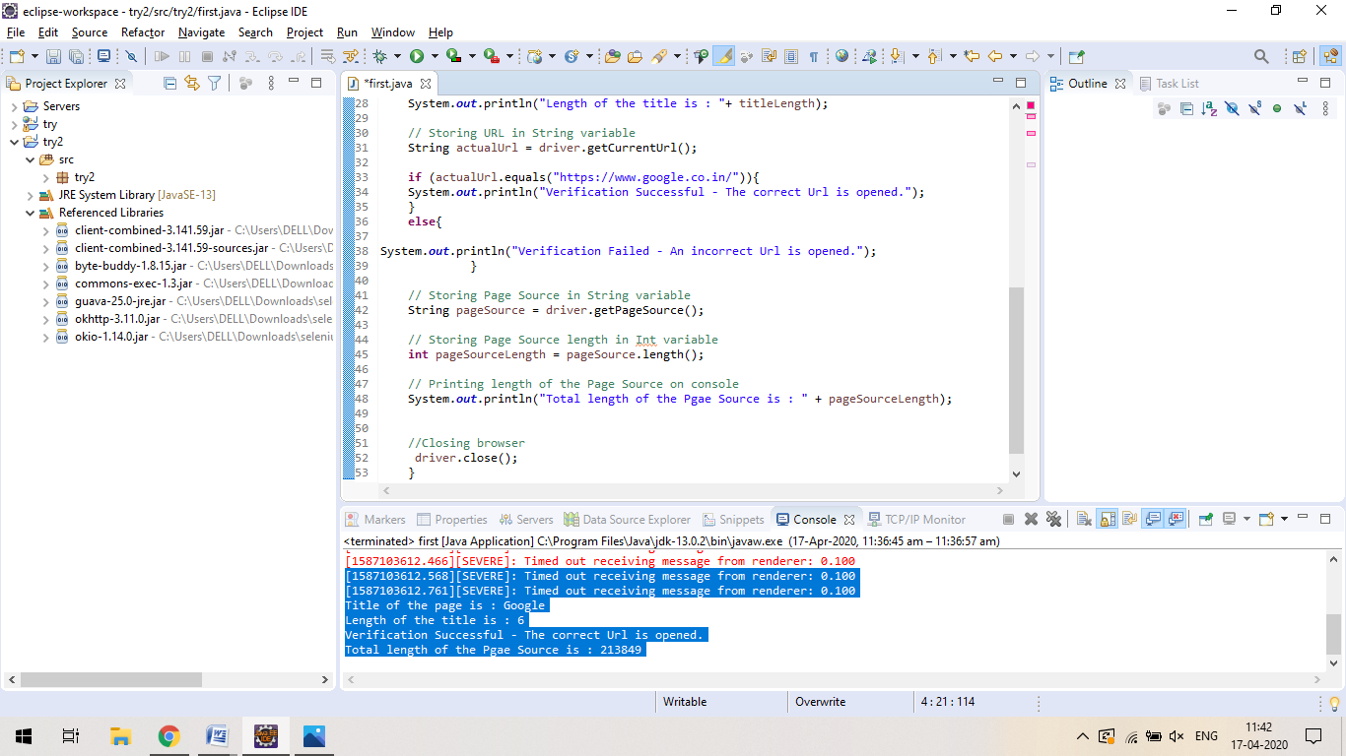

***LAB EXERCISE 8***

Aim: Selenium WebDriver

Perform Automation testing using Selenium Web Driver for testing a web page.

* Open selenium ide and start recording

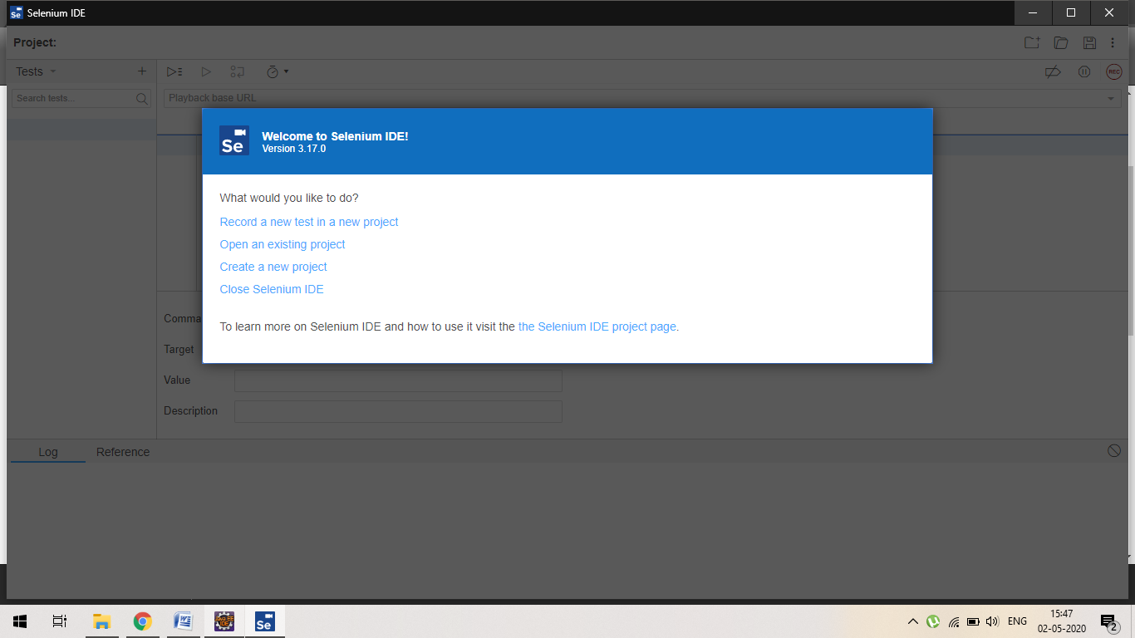

***Output***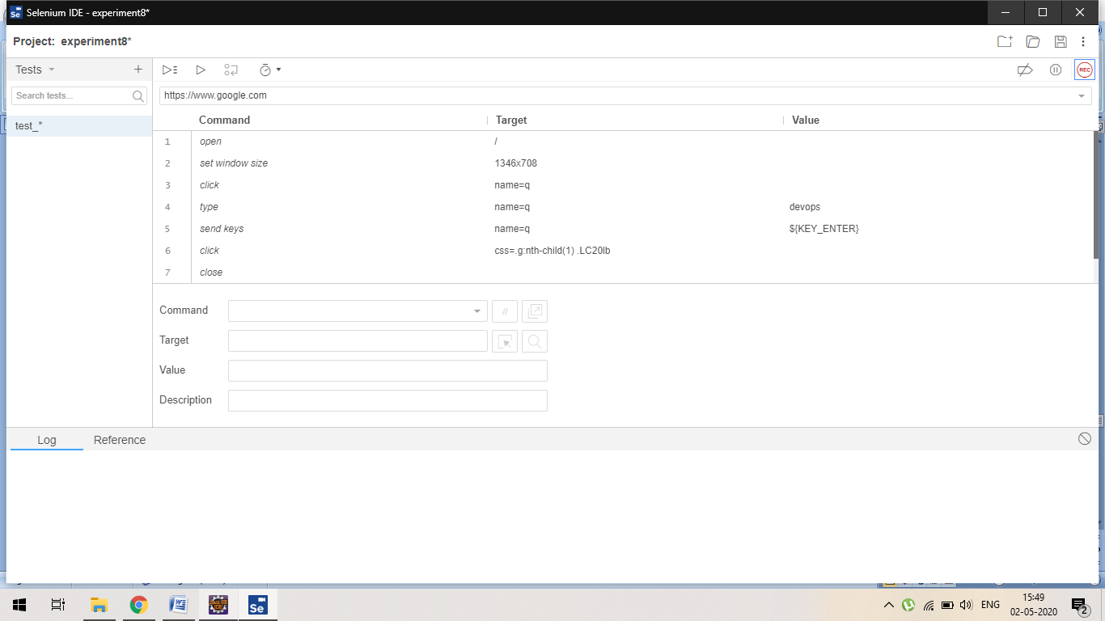

Or we can personally set the

1. Command and
2. Target and
3. Value

***LAB EXPERIMENT -9***

Name : Kushagra Bansal Roll_No : R171218116 Sap_ID : 500067414

***Aim: Build Profile using Maven***

1. ***Per project***

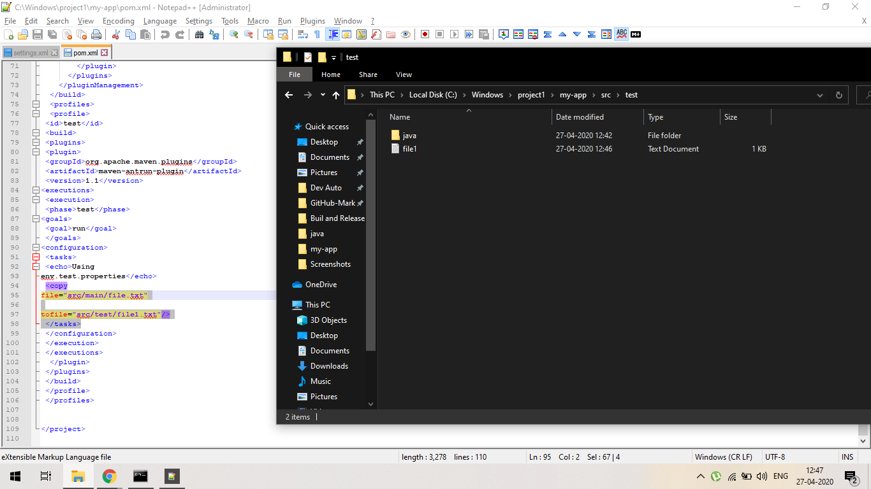

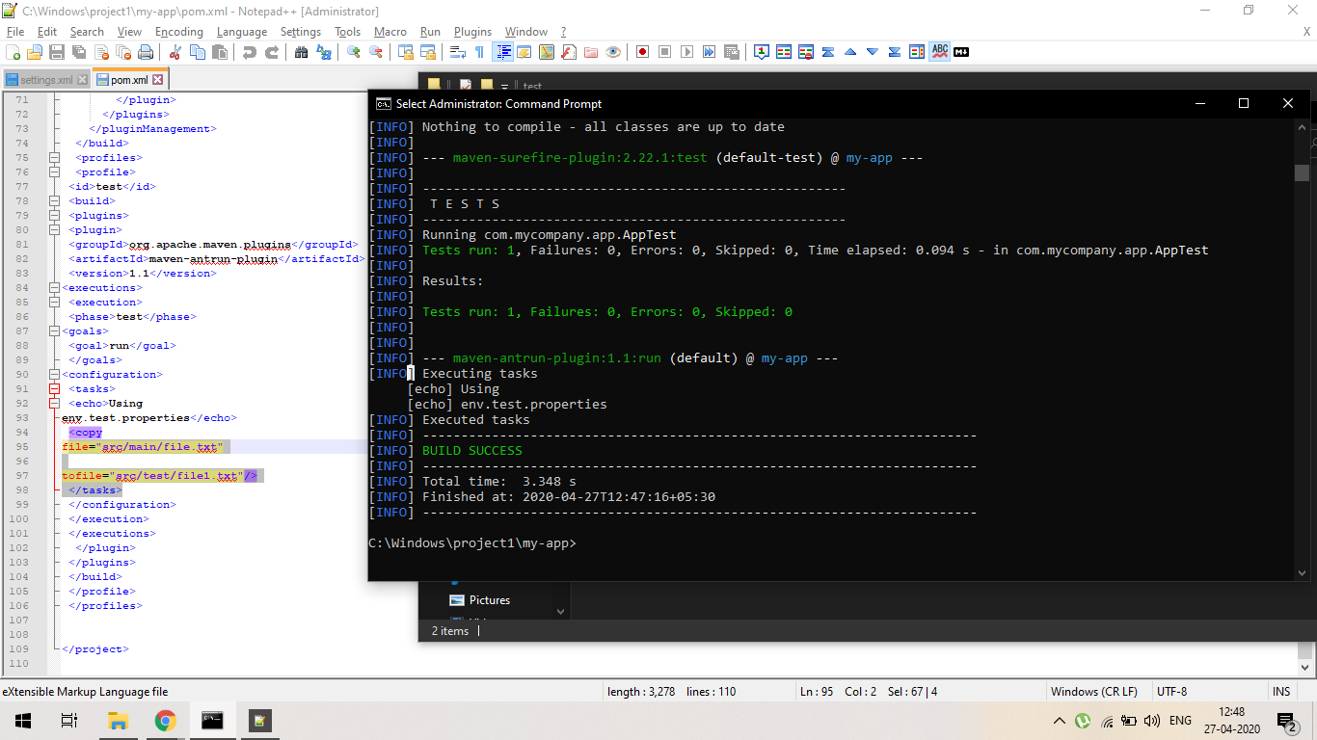

1. ***Per user :***

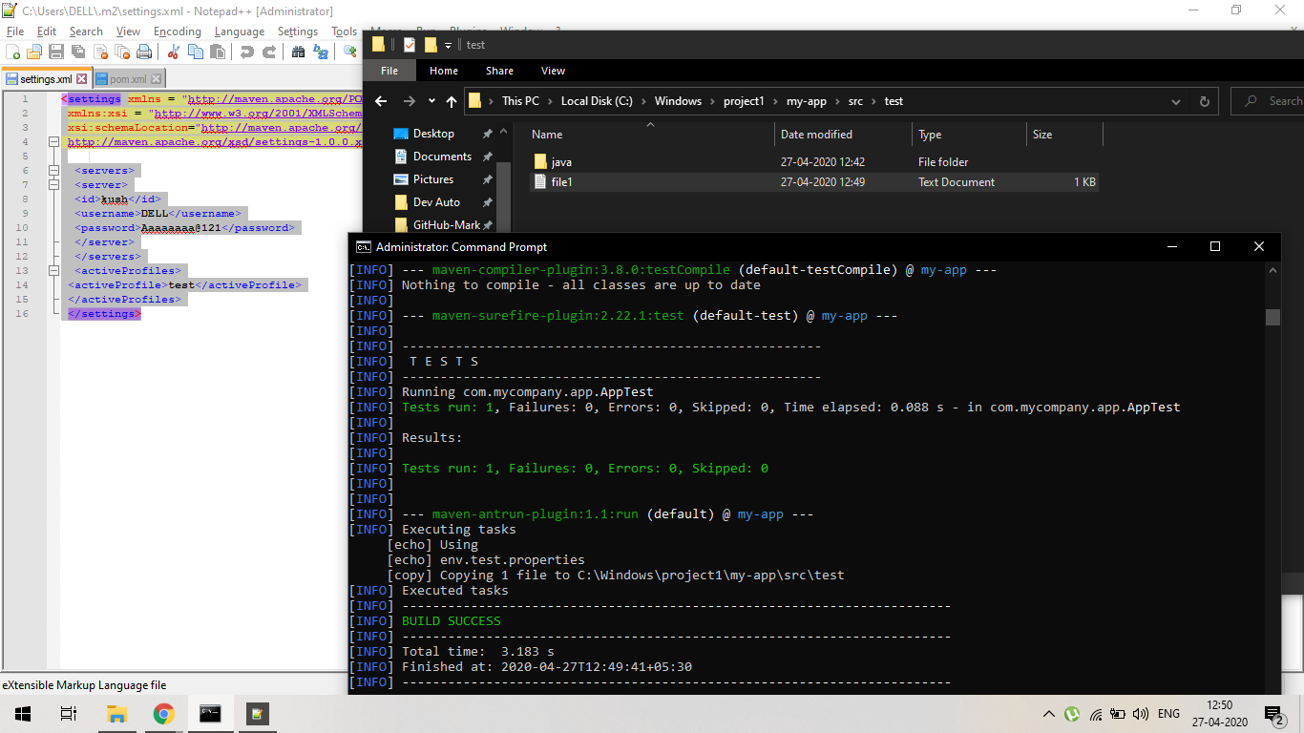

1. ***GLOBAL :***

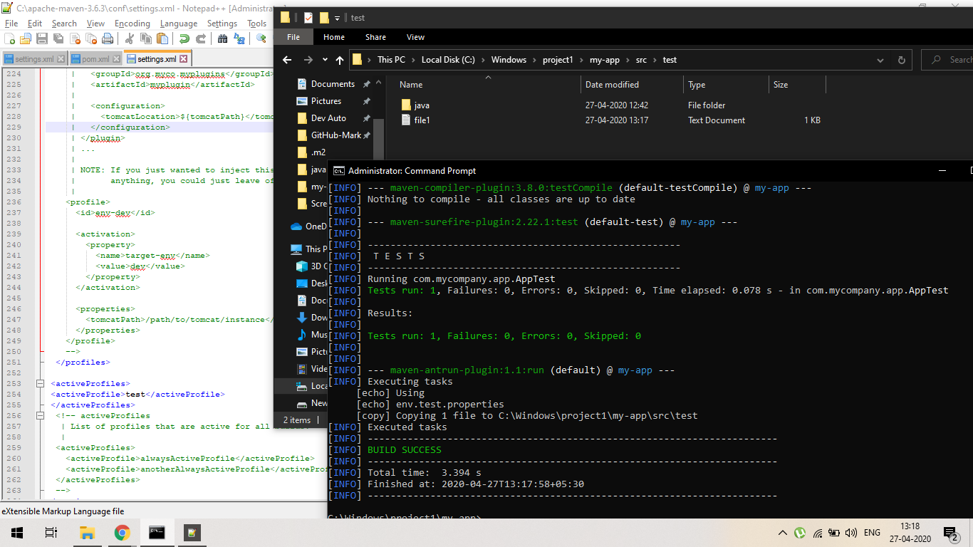

1. ***Activating profile having default <activeByDefault> true :***

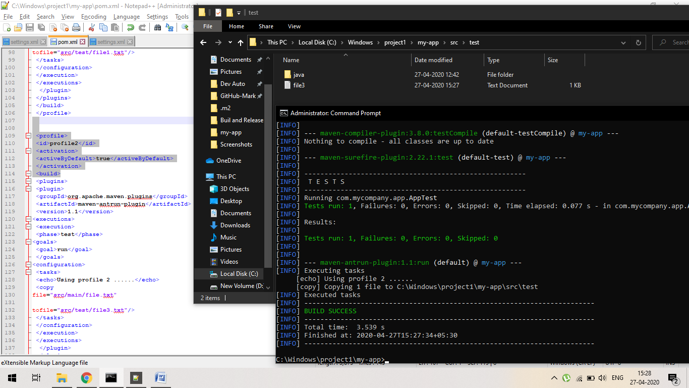

1. ***Activating profile of all maven project having same id:***

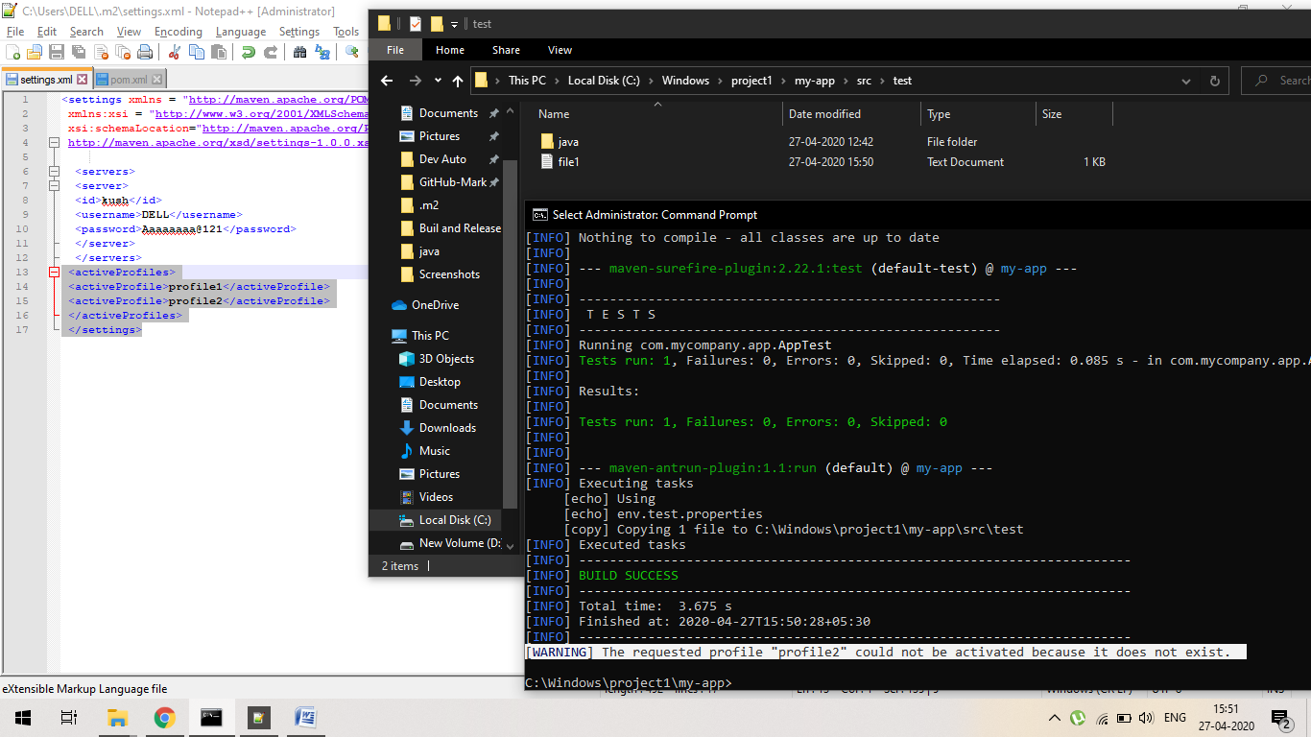

1. ***Activating profile of particular variable and its value***:

***Command use*** : mvn test –Denv=test

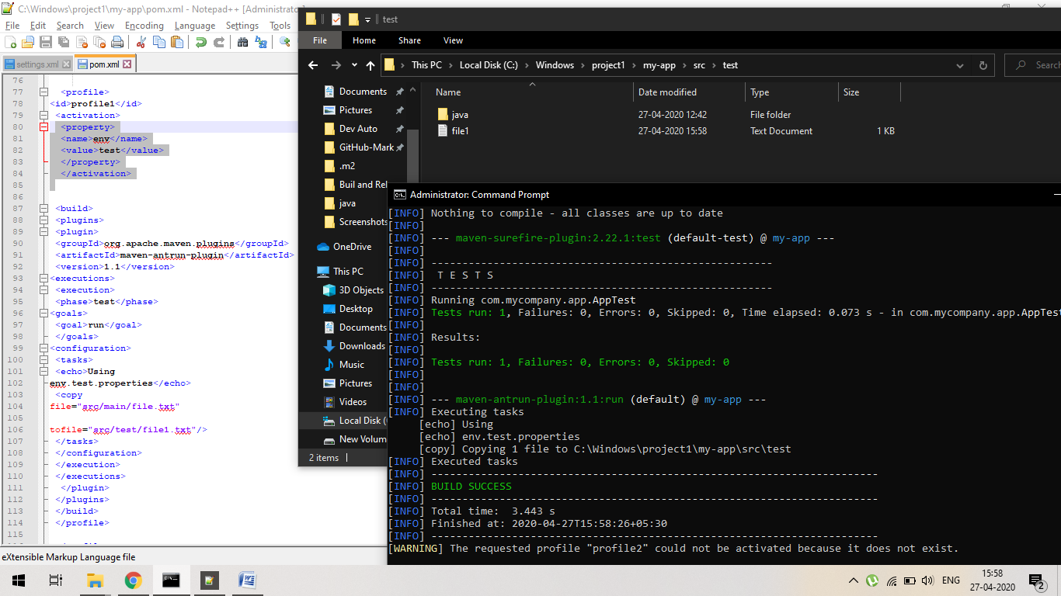

1. ***Copying the missing file from the project:***

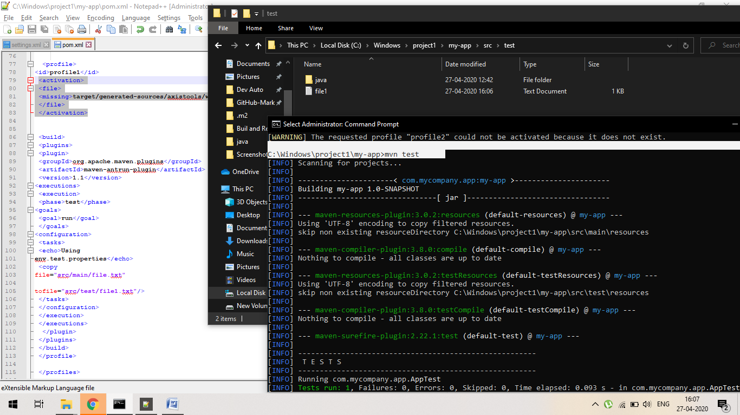

***EXPERIMENT 10***

**Aim: Integration using GitHub**

Create a complete Maven project and push in GitHub repository for Continuous Integration.

